BBC Technical Test

Document listing files and their use in the BBC tech test.

By Alexander Spencer

# Assumptions of the task.

Though the task given was to create a game of life, being able to modify it or allow users to interact with the simulation during its varying iterations is expected. The reasons for the usage of HTML, CSS and JavaScript over other languages such as python and java is due need for quick development in the given period and fact that JavaScript as a scripting based language.

# Index.html

Index.html found in the folder and in the image below is the main page which hosts the rendered game of life from life.js.

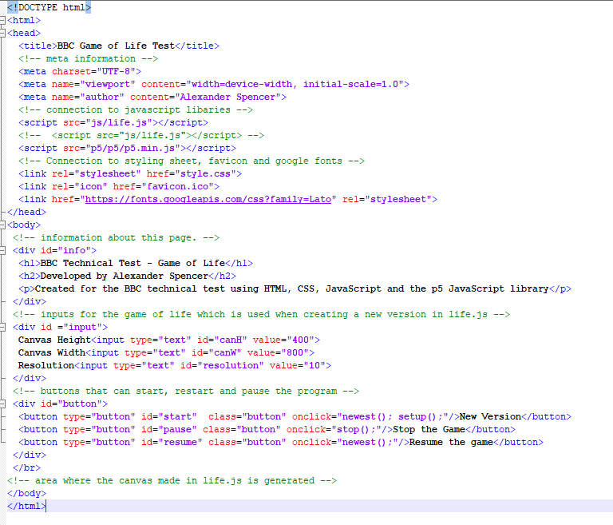

# Style.css

Style.css alters the font, alignment and colour of the text and buttons on the webpage.

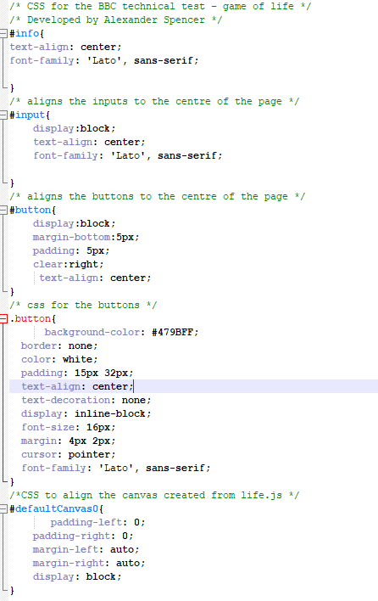

# Life.js

Life.js is the main JavaScript file which computes the 2d grids, which cells are alive, their next generations and for the creation of new versions, pausing the current version and unpausing the current version.

